**My Taxi Service:**

**Project PLAN**

Julián David Gallego García

Politecnico di Milano january 28, 2016



CONTENTS

1. Introduction - 4 -

1.1. Purpose and scope  - 4 -

1.2. List of Definitions and Abbreviations - 4 -

1.3. List of Reference Documents - 4 -

1.4. Overview - 5 -

2. Project Plan - 6 -

2.1. Function points - 6 -

2.1.1. Internal Logic File: - 6 -

2.1.2. External Interface File - 6 -

2.1.3. External Input - 6 -

2.1.4. External Output - 7 -

2.1.5. External Inquiry - 7 -

2.1.6. Total FP numbers - 7 -

2.2. COCOMO Approach - 8 -

2.3. COCOMO computation - 9 -

2.3.1. Evaluation using COCOMO II tool - 9 -

2.3.2. Results of COCOMO II tool - 10 -

2.4. Schedule - 11 -

2.4.1. Tasks: - 11 -

2.4.2. Tasks duration and dependencies - 12 -

2.4.3. Allocation of the resources for the project - 13 -

2.5. Risks analysis - 14 -

2.5.1. Project risks - 14 -

2.5.2. Technical risks - 14 -

# Introduction

## Purpose and scope

The goal of this project is to optimize the taxi service in a large city through a web application and a mobile app. These applications allow the passengers to request a taxi in an easy way and the taxi drivers to have a fair management of taxi queues. This document has the goal to present the principal aspects to start the activities related to the develop of the project, that aspects are, effort, how many people are need it, time that will be expended, the cost, the schedule and the risks.

This document is the Integration Test Plan Document for the system My Taxi Service project. This document is intended for the development team and stakeholder, highlighting the effort need it to develop the target, the time need it and the distribution of task and the risks that will affront the project.

## List of Definitions and Abbreviations

**COCOMO:** Constructive Cost Model

**RASD:** Requirements analysis and specification document.

**DD:** Design Document.

**ILF:** Internal Logic File.

**ELF:** External Interface File

## List of Reference Documents

RASD: Julian Gallego, Requirements analysis and specification document for My taxi service.

DD: Julian Gallego, Design document for My taxi service.

CID: Julian Gallego, Code inspection document.

ITPD: Julian Gallego, Integration Test Plan document for My taxi service.

Specification document: Software Engineering 2 Project, Structure of the project plan document.

## Overview

The document is organized in:

* **Section 2.1-2.3:** Present an approximation of the effort need to accomplish the develop of the system, the quantity of persons required and the cost, all this using a tool call COCOMO II and based on the function points.
* **Section 2.4:** It will be enunciated all the tasks that will be need it to be done to create the system, then the schedule of this tasks will be presented a comparison if the develop team have more persons.
* **Section 2.5:** The possible risks that the team will have to solve in the program development and deployment of the system.

# Project Plan

## Function points

The following table outline the number of Functional Point based on functionality and relative complexity:

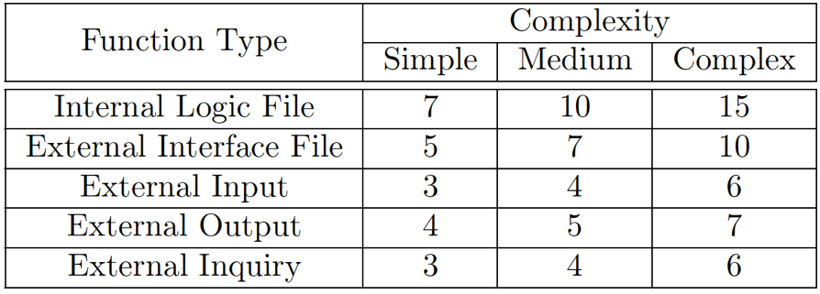

### Internal Logic File:

The application stores the information about

* Users
* Queues
* Position
* Requests.

Each of these entities has a simple structure as it is composed of a small number of fields. Thus, we can decide to adopt for all the four the simple weight.

Thus, 4 x 7 = 28 FPs concerning ILFs.

### External Interface File

It represents a set of homogeneous data used by the application but handled by external application. In the Taxi Service application there are no such functions 0 FPs concerning ELFs.

### External Input

The application interacts with the users as follows:

Users registration: this operation involves one entity, the users. It can still be considered simple, so, its adopted the simple weight. 1 x 3 = 3 FPs

Login/logout: these are simple operations, so its can adopt the simple weight for them.

2 x 3 = 6 FPs

Manage personal information: this operation involves one entity, the users. It can be considered medium, so, its adopted the weight. 1 x 4 = 4 FPs

Change taxi drivers’ status: This operation involves three entities, the users, the queues and the position. It can be considered medium complexity. 1 x 4 = 4 FPs

Request a Taxi: This operation involves two entities, the request and the position. It can be considered medium complexity. 1 x 4 = 4 FPs

Accept/decline a taxi request(driver): This operation involves one entity, the Queues. It can be considered simple complexity. 1 x 3 = 3 FPs.

### External Output

After Registration, the application will send an email validation to the creator of the user this operation involves two entities, user and notification; this can be considered medium cost. 1 x 5 = 5 FPs.

### External Inquiry

The application allows customers to request information about:

* Their personal information.
* Notification about the ride.

Are two different external inquiries that can be consider of medium complexity. 2 x 4 = 8 FPs.

### Total FP numbers

At the end, taking into account all the the point for every aspect related to the function points its arrived to a total of 65 function points, this way:

ILFs: 28

ELFs: 0

External Inputs: 24

External Outputs: 5

External Inquiries: 8

Total Estimate: 65.

## COCOMO Approach

To pass from FP to SLOC its used an average conversion factor of 46 as described at http://www.qsm.com/resources/function-point-languages-table.

$$65FPs*46=2990 SLOC$$

A first estimation is based on FPs approach converted to SLOC. We Consider a project with all “Nominal” Cost Drivers and Scale Drivers would have an EAF of 1.00 and exponent E of 1.0997. Following this formula

$$effort=2.94*EAF*{\left(KSLOC\right)}^{E}$$

where:

EAF: Effort Adjustment Factor derived from Cost Drivers.

Exponent derived from Scale Drivers.

Its obtain

$$effort=2.94*\left(1.0\right)*{\left(2990\right)}^{1.0997}=9.8 Person/months$$

Now its try to calculate the schedule (duration) of project in month with the

following formula

$$Duration=3.67*{effort}^{E}$$

We consider an exponent E of 0.3179

$$Duration=3.67*{9.8}^{0.3179}=7.58 months$$

Now its can be estimate the number of people needed to complete the project with

the following formula

$$Npeople=effort/duration$$

$$Npeople=9.8/7.58 =1 person$$

The result of the Npeople is exactly 1.2 people, knowing that you can’t have that quantity of persons and the fractional is very small its chosen 1 as result, that is a good result taking into a count that the project was mean to be for 1 person.

## COCOMO computation

### Evaluation using COCOMO II tool

To give a more precise estimation adjusting some Scale Driver. To evaluate the COCOMO II and determine the effort required to complete the software project we also use an online tool that helps us to do some calculus (<http://csse.usc.edu/tools/COCOMOII.php)>. Its added the choices made about the Scale Driver to adjust the parameters to the project characteristics and the result report of that site.

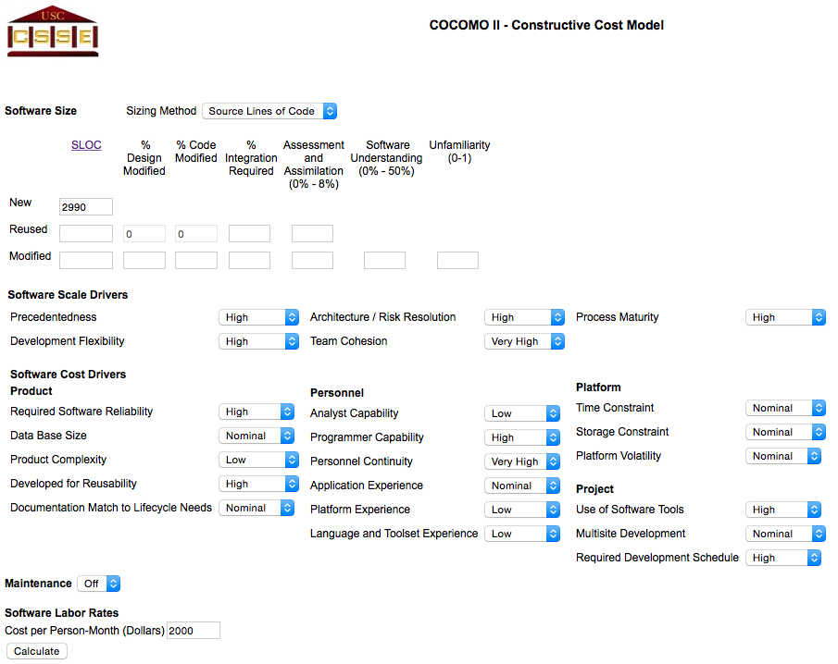

### Results of COCOMO II tool

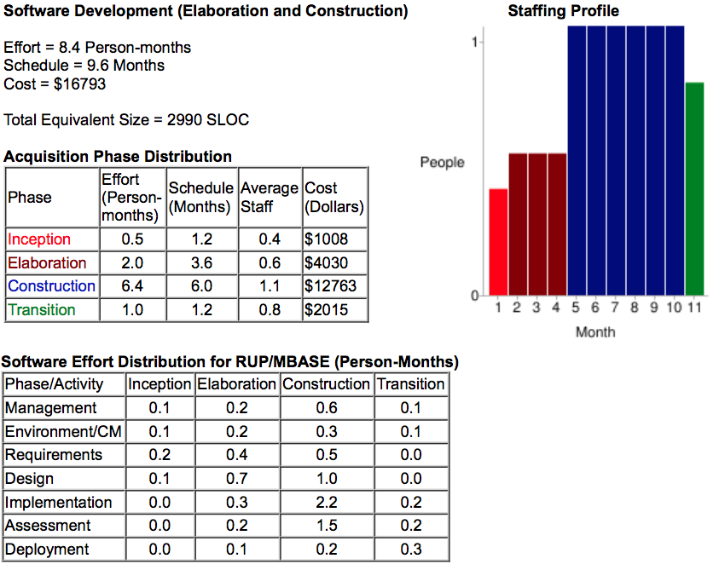

## Schedule

### Tasks:

* **M1 Requirements analysis and specification document:**

T1 Define Goals, assumptions, constraints and dependencies for the systems.

T2 Define System attributes, functional requirements, software functions.

T3 Define Software interface requirements.

T4 Do the alloy model of the system.

T5 Define the scenarios, use cases and class diagram.

T6 Writing of the document with the correct format parting from all the work made so far.

* **M2 Design Document:**

T7 Define architectural style and patterns

T8 Define High levels components, description and deployment view.

T9 Define Run time view and sequence diagrams.

T10 Define Algorithm design, experience diagram and requirements traceability.

T11 Writing of the document with the correct format parting from all the work made so far.

* **M3 Code inspection document:**

T12 Review Naming conventions, Indention, Braces, Consistent Allman style, File and Organization on the code.

T13 Review Wrapping lines, Comments, Java source files, Package and import statements and Class and interface declarations on the code.

T14 Review Initialization and declarations, Method calls, Arrays, Object comparison ad Output Format on the code.

T15 Review Computation, comparisons and assignments Exceptions, Flow of control and Files on the code.

T16 Writing of the document with the correct format parting from all the work made so far.

* **M4 Integration Plan Document:**

T17 Define the Integration strategy, entry criteria, elements to be integrated

T18 Define integration sequence, individual steps and test description

T19 Define Test Procedures

T20 Describe tools, Test Equipment, program stubs and test data require.

T21 Writing of the document with the correct format parting from all the work made so far.

* **M5 Project Plan Document:**

T22 Identify the function points then using COCOMO estimate the effort and cost of the system.

T23Identify the tasks of the project and their schedule.

T24 Assign the tasks to the available members of the group.

T25 Define the risks for the project, their relevance and recovery actions

T26 Writing of the document with the correct format parting from all the work made so far.

### Tasks duration and dependencies

#### Timetable of work made during the semester for the project.

|  |  |  |  |  |  |
| --- | --- | --- | --- | --- | --- |
| **Document** | **Tasks** | **Start date** | **Finish date** | **Duration** | **Dependencies** |
| Requirements analysis and specification document | T1 | 22/10/15 | 23/10/15 | 2 days |  |
| T2 | 24/10/15 | 25/10/15 | 2 days |  |
| T3 | 26/10/15 | 29/10/15 | 3 days | T1,T2 |
| T4 | 30/10/15 | 02/11/15 | 4 days |  |
| T5 | 03/11/15 | 03/11/15 | 1 day | T2 |
| T6 | 04/11/15 | 06/11/15 | 3 days | T1,T2,T3,T3,T5 |
| Design document for My taxi service | T7 | 12/11/15 | 13/11/15 | 2 days | M1 |
| T8 | 14/11/15 | 14/11/15 | 1 day | T7 |
| T9 | 15/11/15 | 19/11/15 | 5 days | T5,T8,M1 |
| T10 | 22/11/15 | 24/11/15 | 3 days | T9, M1 |
| T11 | 01/12/15 | 04/12/15 | 4 days | T7,T8,T9,T10 |
| Code Inspection document | T12 | 16/12/15 | 19/12/15 | 4 days |  |
| T13 | 16/12/15 | 19/12/15 | ---- |  |
| T14 | 16/12/15 | 19/12/15 | ---- |  |
| T15 | 16/12/15 | 19/12/15 | ---- |  |
| T16 | 02/01/16 | 04/01/16 | 3 days | T12,T13,T14,T15 |
| Integration Plan document | T17 | 16/01/16 | 16/01/16 | 1 day | T8 |
| T18 | 17/01/16 | 17/01/16 | 1 day | T17,M1,M2 |
| T19 | 18/01/16 | 18/01/16 | 1 day | T18,M1,M2 |
| T20 | 19/01/16 | 19/01/16 | 1 day | T17,T18,T19,M2 |
| T21 | 20/01/16 | 21/01/16 | 1 day | T17,T18,T19,T20 |
| Project Plan document | T22 | 23/01/16 | 23/01/16 | 1 day | M1,M2,M3,M4 |
| T23 | 23/01/16 | 23/01/16 | ---- |  |
| T24 | 24/01/16 | 24/01/16 | 1 day | T23 |
| T25 | 24/01/16 | 24/01/16 | ---- |  |
| T26 | 25/01/16 | 25/01/16 | 1 day | T22,T23,T24,T25 |
| Total Time | | | | 45 days | |

### Allocation of the resources for the project

#### Timetable of work made during the semester for the project is the work was made with a partner.

|  |  |
| --- | --- |
|  | Responsible |
|  | Integrant 1 |
|  | Integrant 2 |
|  | All |

|  |  |  |  |  |  |  |
| --- | --- | --- | --- | --- | --- | --- |
| **Document** | **Tasks** | **Start date** | **Finish date** | **Duration** | **Dependencies** |  |
| Requirements analysis and specification document | T1 | 22/10/15 | 23/10/15 | 2 days |  |  |
| T2 | 22/10/15 | 23/10/15 | 2 days |  |  |
| T3 | 24/10/15 | 26/10/15 | 3 days | T1,T2 |  |
| T4 | 24/10/15 | 27/10/15 | 4 days |  |  |
| T5 | 27/10/15 | 27/10/15 | 1 day | T2 |  |
| T6 | 28/10/15 | 29/10/15 | 2 days | T1,T2,T3,T3,T5 |  |
| Design document for My taxi service | T7 | 12/11/15 | 12/11/15 | 1 day | M1 |  |
| T8 | 13/11/15 | 13/11/15 | 1 day | T7 |  |
| T9 | 14/11/15 | 16/11/15 | 3 days | T5,T8,M1 |  |
| T10 | 17/11/15 | 18/11/15 | 2 days | T9, M1 |  |
| T11 | 01/12/15 | 02/12/15 | 2 days | T7,T8,T9,T10 |  |
| Code Inspection document | T12 | 16/12/15 | 17/12/15 | 2 days |  |  |
| T13 | 16/12/15 | 17/12/15 | ---- |  |  |
| T14 | 16/12/15 | 17/12/15 | ---- |  |  |
| T15 | 16/12/15 | 17/12/15 | ---- |  |  |
| T16 | 02/01/16 | 02/01/16 | 1 day | T12,T13,T14,T15 |  |
| Integration Plan document | T17 | 16/01/16 | 16/01/16 | 1 day | T8 |  |
| T18 | 17/01/16 | 17/01/16 | 1 day | T17,M1,M2 |  |
| T19 | 18/01/16 | 18/01/16 | 1 day | T18,M1,M2 |  |
| T20 | 19/01/16 | 19/01/16 | 1 day | T17,T18,T19,M2 |  |
| T21 | 20/01/16 | 20/01/16 | 1 day | T17,T18,T19,T20 |  |
| Project Plan document | T22 | 23/01/16 | 23/01/16 | 1 day | M1,M2,M3,M4 |  |
| T23 | 23/01/16 | 23/01/16 | ---- |  |  |
| T24 | 24/01/16 | 24/01/16 | 1 day | T23 |  |
| T25 | 24/01/16 | 24/01/16 | ---- |  |  |
| T26 | 25/01/16 | 25/01/16 | 1 day | T22,T23,T24,T25 |  |
| Total Time | | | | 28 days | | |

Looking the total time from the two tables, working 2 persons on the project the time that its need need it to accomplish is reduced to the half and the most important the workload is reduced considerably.

## Risks analysis

### Project risks

**Underestimated development time:** underestimation of the time necessary for accomplish a task, the relevance of this problem on the project is very high and the probability to this to happen is high, because it can slip the project schedule and increase the costs. The recovery action for this problem is finish the task in the shortest time possible and reschedule trying to recovery the time lost cutting time in the tasks that are less critical or easy to accomplish.

**Requirements changes:** changes on the goals or the functionalities of the project, the relevance is also very high and the probability to this to happen is moderate, because it will slip the project schedule and increase the costs. The recovery action for this problem is first make the changes that can be implement immediately then have a pre delivery of the product on the programed date without the new features that couldn’t be implemented if them don’t change dramatically the implementation of the final product or reschedule and postpose the delivery of the final project if it does.

### Technical risks

**The database used in the system cannot process as many transactions per second as expected:** the relevance is moderate and the probability to this to happen is moderate, this will increase the costs. The recovery action for this if the flow of transactions grow so much will be the change of the database to a one that can handle it.

**Problems with the communication network:** the relevance is high and the probability to this to happen is low, this will have terrible repercussions on the service. The recovery action from this will be contact the enterprise in charge on the service and ask them for solutions, in the mean time have everything ready to restart the service when the communication will be ok again.

**Staff illness:** The relevance is moderate and the probability to this to happen is moderate, this will have repercussions on the workload of the other workers and will slow down some process. The recovery action for this will be the reorganize of the work team so that there is more overlap of work and people therefore understand each other’s jobs.

**Staff conflicts:** The relevance is moderate and the probability to this to happen is moderate, this will have repercussions on the workflow and slow down some process. The recovery action for this will call a meeting with the persons involved in the problem and the human resources manager to deal with the problem, if the problem persists, reorganize the work team so the conflicts part not will longer be working together.